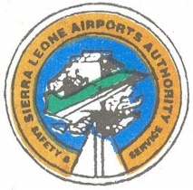
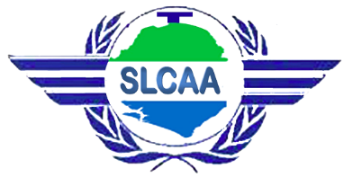
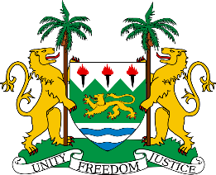

TRAVEL ADVISORY
Following the declaration made by His Excellency Brig. (Rtd) Julius Maada Bio on the resumption of commercial flight operations on the 22ndJuly 2020, the Government of Sierra Leone through the Ministry of Transport and Aviation in collaboration with the Ministry of Health and Sanitation, Sierra Leone Civil Aviation Authority, Sierra Leone Airports Authority and the National COVID-19 Emergency Response Centre (NACOVERC) publishes the following safety and public health guidelines which shall be strictly adhered to by all arriving and departing passengers at/from the Freetown International Airport.
ARRIVING PASSENGERS
- All passengers shall produce a negative Polymerase Chain Reaction (PCR) COVID-19 test result issued no longer than 72hrs before departure at point of origin.
- At the check-in desk at the airport of embarkation, passengers are required to display travelers’ authorisation to Sierra Leone, received through the Government of Sierra Leone travel portal (www.travel.gov.sl). The travel authorization consists of:
- Negative PCR COVID-19 test result issued no longer than 72 hours before departure,
- Pre-departure public health passenger locator form
- Proof of payment for COVID-19 testing on arrival, paid through the online platform
- Health officials will collect temperature, basic health screening data, and seat number on arrival.
- All passengers shall be subjected to a mandatory COVID-19 test upon arrival:
- Passengers will simultaneously have a PCR test swab and an RDT test on arrival.
- If the RDT screening is negative, passengers are allowed to depart from the airport and observe public health protocols (mandatory proper mask wearing, hand washing, and physical distancing) while awaiting their PCR test result.
- If the RDT screening if positive, passengers will be isolated at a hotel in Lungi while awaiting their PCR test result. Note, the cost of the accommodation at the hotel shall be borne by the passenger.
- For all test results, the PCR result supersedes the RDT result.
- PCR results will be disseminated via the local contact number confirmed by the passenger on arrival.
- All children under 2 years shall be exempted from pre-departure and arrival PCR test requirements.
- Airline crew are exempted from the pre-departure and arrival PCR test requirements and should follow airline policy for testing. Airline crew must adhere to public health protocols.
- Two temperature screenings will be conducted by Port Health Services. If temperature is 37.5 degrees Celsius or above, passenger will be taken aside for further observation.
- All passengers shall go through a walk-through disinfectant channel/Infrared temperature scanner at the entrance of the arrival hall.
- All passengers with machine-readable passports shall go through the Immigration E-gate system. Passengers with Emergency Travel Certificates or non-machine-readable passports shall go through the Immigration booth.
- At the Baggage Reclaim section passengers shall maintain social distancing and observe all public health protocols, including proper use of face mask at all times.
- All passengers will be directed to a Reception Lounge while awaiting their COVID-19 test.
- Passengers with a negative RDT screening test are cleared to proceed to their destination, while awaiting their PCR result and adhering to public health protocols. PCR test results (available in no more than 48 hours) will be distributed via the contact confirmed on arrival.
- If a passenger’s PCR test is positive, s/he will be contacted by public health authorities and taken to an appropriate treatment centre.
- Passengers sitting near a positive case on the plane will be considered primary contacts. Self-quarantine and monitoring by public health officials will be required.
- All passengers are strictly advised to observe all public health protocols (proper and constant use of face mask, hand washing/sanitizing, observing social distancing) as directed by the Ministry of Health and Sanitation / NaCOVERC.
- The same protocols shall apply to all VIP passengers.

DEPARTING PASSENGERS
- All passengers are subjected to a mandatory Polymerase Chain Reaction (PCR) COVID-19 test with a negative result issued no longer than 72hrs before departure at the Freetown International Airport. Cost for this test will be borne by the passenger.
  - Passengers will use the Government of Sierra Leone Travel Portal to request their pre-departure test, to pay for the test, and for scheduling sample collection.
  - Passengers with negative PCR results will receive e-confirmation and certificates ahead of travel. Physical copies can be collected at the airport at a designated desk.
  - Passengers with positive PCR results will not be permitted to travel and must follow public health protocols for isolation and contact tracing. They will be re-tested after seven days.
  - Passengers who have entered Sierra Leone within five days shall be exempted from the mandatory additional test on departure.
  - All children under 2 years shall be exempted from PCR test requirements.
- On arrival at the airport, passengers shall be directed to a reception area to avoid congestion and ensure social distancing during the check-in process.
- All passengers are encouraged to complete their check-in online before arriving at the airport.
- All departing passengers shall go through the thermal screening/disinfectant channel at the airport’s departure entrance.
- All departing passengers shall have their passport/travelling document verified before proceeding to the check-in counter.
- Departing passengers shall proceed to the check-in counter for baggage drop and collection of their boarding pass. While at the check-in counter, they are mandated to produce their COVID-19 PCR negative test certificate or e-certificate issued within past 72 hours.
- Departing passengers shall proceed to the immigration services for onward travel authorization via the e-gate or immigration booth.
- All departing passengers shall go through security screening before proceeding to the departure hall.
- All departing passengers shall proceed to the waiting lounge where social distancing, proper use of face mask and other health protocols shall be strictly observed.
- All passengers shall proceed to the final screening and verification point prior to boarding the aircraft.
- Boarding procedures shall be in accordance with the approved SOPs of the respective airlines.
- All passengers are strictly advised to observe all public health protocols (proper use of face mask, hand washing/sanitizing, observe social distancing) as directed by the Ministry of Health and Sanitation / NACOVERC.
- The same protocols shall apply to all VIP passengers.

